RESUME

BAKHT ZAMAN

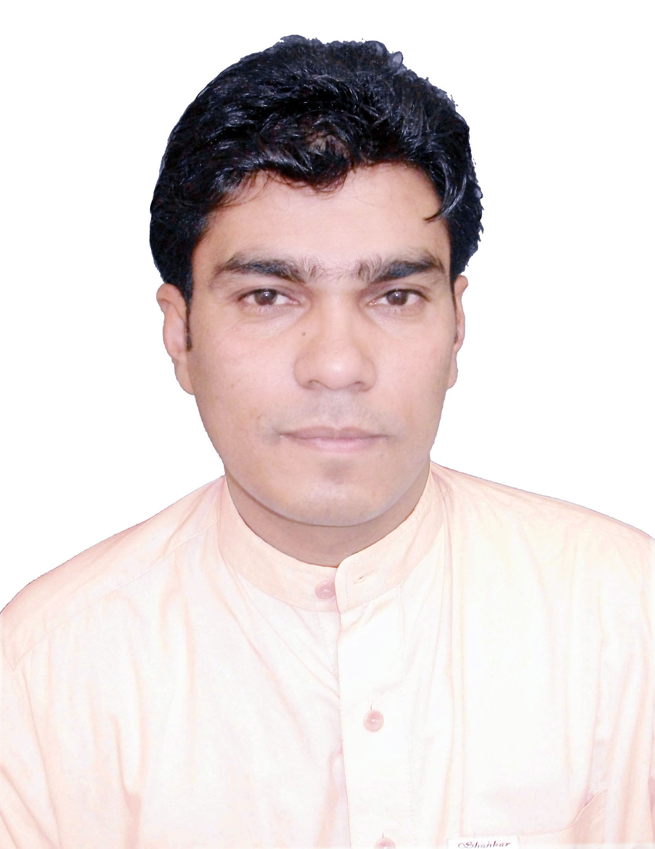
Ph.D Scholar (Journalism & Mass Communication)

Father’s Name: Abdul Qadir
Date of Birth: 5th January 1976
Domicile: District Haripur (Khyber Pakhunkhwa)
Postal Address: Assistant Professor/Executive Producer, Campus Radio
Department of Journalism and Mass Communication
University of Peshawar
Cell: 0092-300-9599545
Email: bakhtzaman@gmail.com
bakhtzaman@uop.edu.pk

Educational Qualification

Exam | Board/University | Session | Marks | Division
M.Phil  (Media Studies) | University of Peshawar | 2015 | 3.70CGPA | 3.70CGPA
M.A Journalism  (Gold Medalist) | University of Peshawar | 1998 | 702/1100 | 1st Class
B.A | University of Peshawar | 1996 | 323/550 | 2nd
F.A | B.I.S.E Abbott Abad | 1993 | 576/1100 | 2nd
SSC | B.I.S.E Abbott Abad | 1991 | 519/850 | 1st

Distinctions/Awards:
- Recipient of Gold Medal from University of Peshawar in 1998
- Recipient of Orient Hameed Nizami Award
- Appreciation Certificate from Vice Chancellor, University of Peshawar for outstanding services as Media and Protocol Officer, UoP
- Appreciation Certificate from Director Vice Chancellor’s Secretariat UoP for outstanding services as Media and Protocol Officer, University of Peshawar.
- Appreciation Certificate from Director Administration, University of Peshawar for meritorious services as Media and Protocol Officer, UoP in Sports Gala 2006.
- Appreciation letter from Mr. Ajmal Khan, Principal Islamia College Peshawar for writing optimistic and positive column on I C P.
- Shield from Students’ Societies, UoP for services as Coordinator Dramatic Society, University of Peshawar.

Languages:
English, Urdu, Pashto,

Experience:
- Working as Assistant Professor/Executive Producer at the Department of Journalism & Mass Communication, University of Peshawar since October, 2015.
- Worked as Lecturer/Executive Producer at the Department of Journalism and Mass Communication, University of Peshawar since December 2007
- Being as Executive Producer, taking care of the live transmission of Campus Radio, and working as Pashto/urdu Compere (live) since its inception.
- Working as a News Anchor (Pashto- live) with PTV Home and PTV National since 2000 in OUTSTANDING CATEGORRY. Also participate in Urdu Khabarnama at 9:00 PM on PTV News.
- Worked as a lecturer in Journalism since October 21, 2002 till December 2007 at Islamia College Peshawar.
- Worked as a Media and Protocol Officer, University of Peshawar since March 21, 2006 till December 2007.
- Worked as an Editor of the University of Peshawar’s Newsletter.
- Worked as Organizer of the Central Media Committee, University of Peshawar.
- Prepared on-camera reports for PTV Peshawar as and when required.
- Attached as script writer and anchor (Parleemani Note Book) with the Current Affairs Section of PTV Peshawar.
- Attached with PBC Peshawar as Compere, Moderator and Anchorperson (Pashto/Urdu- Live) since 2002
- Working as Director of the Radio Drama with Campus Radio, University of Peshawar.
- Working as a Joint Editor with Campus Bulletin, University of Peshawar.
- Worked as a Compere and Scriptwriter with AVT Khyber, Pashto TV Channel.
- Worked as a Reporter and Interpreter with TV Asahi Japan during the War Against Terrorism in 2002.
- Worked as a Columnist with urdu daily Mashriq, Peshawar for two years.(2001-2003)
- Had been writing editorial and regular column for Urdu daily “Subh” Peshawar for the three years.
- Wrote column for Pashto daily “Khabroona” Peshawar.
- Remained coordinator of the Khyber Union Hall, Islamia College University Peshawar
- Wrote scripts for documentaries of the current affairs section of PTV Peshawar.
- Worked with different NGOs as Researcher, Report writer, Coordinator, Media Secretary and Resource Person.
- Worked as Co organizer of the Cultural and Dramatic Society, University of Peshawar.
- Worked as Reporter and narrator with Voice of Germany (Deutsche Welle) at Bonn, Germany: March – May 2010.
- Worked as Deputy Director Students’ Societies, University of Peshawar (Jan 2, 2012 to Dec 5, 2012).
- Media Secretary (Co-Opted Member), Peshawar University Teachers’ Association (PUTA) (Nov 2011 to Nov 2012).
- Media Secretary ( Elected- the first ever) Peshawar University Teachers’ Association (PUTA) (2013-2014)
- Member Senate (Elected) University of Peshawar (November 10, 2014 to April 17, 2015)
- Associated as an Anchorperson with Pashto 1 (AVT Channels) for its current affairs show ‘News & Views’. (March – June 2016).
- Worked as Media Officer (Additional Responsibility), University of Peshawar from Feb 20 – March 10, 2017.

Workshops, Seminars, Trainings (Received/Imparted)

- Training of Trainers in Journalism (TOT) Feb 25 – 29, 2008, organized by Friedrich Ebert Stiftung (FES) at Karachi.
- One month training on Radio Drama (acting, writing, technical) at Lincoln Corner, University of Peshawar (June 2008) organized by (EARS, Inc), Educational Arts Resource Service Inc, USA
- Workshop on “ Data analysis ad Research Proposal Writing” (Feb 17-18,2009) at HEC Peshawar
- Five-day workshop on “Effective Professional Communication” (Jan 18 – 22, 2010) at Staff Training Institute, University of Peshawar.
- Three-month Fellow ship at Deutsche Welle (Voice of Germany) Bonn, Germany (March 01- May 29, 2010) sponsored by Friedrich Ebert Stiftung (FES).
- Training workshop on “Educational TV Programme for Children and Youth, Module 1” (July 19- 31, 2010) at Bara gali campus, jointly organized by DW TV Berlin (Germany) and Department of Journalism and Mass Communication, University of Peshawar.
- Training workshop on “Educational TV Programme for Children and Youth, Module 2” (October 4- 23, 2010) at Islamabad, jointly organized by DW TV Berlin (Germany) and Department of Journalism and Mass Communication, University of Peshawar.
- Training of Trainers (TOT) Oct 23- 25, 2010 at Islamabad, organized by Friedrich Ebert Stiftung (FES).
- FLP Grand Jarga (Sep 09-12, 2011) at Baragali summer camp, UoP.
- Training of Trainers (TOT- Curriculum Designing for Campus Radio Stations) Sept 21 -30, 2011 at Islamabad by Internews.
- Faculty Development Programme, visit to different academic and media institutions in (Washington DC and Washington State) USA (Oct 22 to Nov 07, 2011).
- “Open Forum on FATA Reforms – A way forward” Dec 12-14, 2011, organized b by University of Peshawar in collaboration with Internews Pakistan.
- Workshop on “Peace and conflict resolution in 21st century” (March 15- 17, 2012) at Staff Training Institute, University of Peshawar.
- Training on “Internet Politics” at University of Erfurt, Germany June 20- July 01, 2012)
- One day workshop on “Intellectual Property Rights (IPRs): Drafting and Filing of Patent Application” on 4th of June, 2015 at, organized by PASTIC, Intellectual Property Organization (IPO) and ORIC at University of Peshawar.
- 5-day training workshop on Equality, Tolerance and Diversity organized by CRSS in collaboration with PACE at COMSATS, Islamabad (March 5 to 9, 2016)
- 3-Day Training/Research Session on Conflict Sensitive Journalism, Psychological Risks, Media Ethics and Digital Security of Journalists (28-30 October, 2016) at Media House, Islamabad.
- International Conference on “Community Media: Prospects and Challenges” organized by Pakistan Journalists’ Forum, UAE (May 05-12) at Ajman, UAE.
- Regional Assembly (Khyber Pakhtunkhwa) organized b CRSS in collaboration with PACE on June, 10, 2017 at Peshawar.

Training Imparted

- 16-week training on Radio Drama (writing, acting, technical) Nov 2, 2009 – Feb 26, 2010 at the Department of Journalism and Mass Communication, University of Peshawar .

- Five-day training on “ Radio Journalism” for journalists of FATA and KP at Baragali Campus, University of Peshawar, organized by Media House Islamabad and HBS Germany (14th -18th September 2013).

- Five-day training on “ Radio Journalism” for female journalists of KP at the department of Journalism & Mass Communication, University of Peshawar, organized by Media House Islamabad and HBS Germany (28th Oct – 2nd Nov 2013).

- Five-day training on “ Radio Journalism” for journalists of KP and FATA at the department of Journalism & Mass Communication, University of Peshawar, organized by Media House Islamabad and HBS Germany (23rd Dec – 27th Dec 2013).

Interviews
- Interviewed Mr. Andrew Collingwood, Senior Manager, Coffey International, for Campus Radio Station (17th of June, 2015)
- Interviewed Mr. Martin Kobler, the Ambassador of Federal Republic of Germany to Pakistan for Campus Radio Station on Sept 13, 2017.

Participations
- Participated in various current affairs and Magazine Programmes of Pashto 1/ Khyber News and AVT Khyber (AVT Channels) as an expert/journalist. (2015-17)
- Participated many times Sports Programmes ‘Howzzat’ of Pashto 1 (AVT Channels) (Feb-March 2016) as Analyst.

Songs/Anthems
- Sung a Peace Song (Qalam /Pen), being played in various events of UoP and other institutions.
- Sung National Patriotic Song (Zama Watan/ My Country), being played by PBC and other radio stations.
- Sung anthems for ‘Peshawar Zalmi’ in 1st and 2nd Editions of Pakistan Super League.

Countries Visited
- Germany, France, Belgium, Netherlands, USA. U.A.E

References:

Will be furnished on demand

